**LEBANESE AMERICAN UNIVERSITY**

**USAID – HIGHER EDUCATION SCHOLARSHIP PROGRAM**

**HES - Volunteering Program Verification Form**

This form is to be used to document volunteering hours. If a student volunteers for multiple organizations, a separate form must be used for each organization. **This form must be turned in by the 28th of each month, the latest.**

I certify that the scholar Lamitta Slika completed a total of 5 hours of service at Life Sculptor.

The hours were completed hours as per the below:

Hours # 0 (date) _30/09 – 5/10_ (initials of supervisor) __A.K.___

Hours # 0 (date) _7/10 – 11/10_ (initials of supervisor) __A.K.___

Hours # 0 date) _14/10 – 18/10 (initials of supervisor) __A.K.___

Hours # 5 date) _21/10 -25/10 (initials of supervisor) __A.K.___

Brief description of the activities the scholar performed or participated in:

Role-playing and experiential exercises to practice cognitive restructurin,Behavioral Activation, Explanation of behavioral activation principles. Identifying behavioral patterns and routines, Setting SMART goals (Specific, Measurable, Achievable, Relevant, Time-bound) Implementing behavioral experiments and graded exposure techniques, Relaxation and Stress Management Techniques,Introduction to relaxation techniques (e.g., deep breathing, progressive muscle relaxation) ,Stress management strategies (e.g., time management, problem-solving), Incorporating mindfulness and acceptance-based approaches  
D. Guided experiential exercises and group discussions on relaxation and stress management. Homework Assignments and Monitoring Progress  
Importance of homework assignments in CBT

Written feedback about the scholar’s performance:

Lamitta's work effectively incorporates role-playing and experiential exercises to enhance understanding of cognitive restructuring and behavioral activation. Her focus on setting SMART goals and implementing relaxation techniques demonstrates a comprehensive approach to mental health practices, fostering both individual growth and group collaboration.

Please rate the overall performance of the scholar at your organization:

|  |  |  |  |
| --- | --- | --- | --- |
|  | Mastery (5) | Proficient (3) | Emerging (1) |
| **Problem solver** | X |  |  |
| **Engaged & Committed** | X |  |  |
| **Open-minded & multicultural** | X |  |  |

Signature

& stamp

__________________________

_

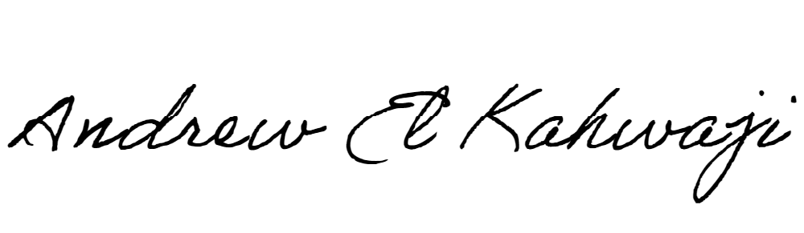

Printed Name _Andrew El Kahwaji_

Date __26/10/2024___

Email __andrew.lifesculptor.coo@gmail.com __

Phone __+961 71 914 378__

**LEBANESE AMERICAN UNIVERSITY**

**USAID – HIGHER EDUCATION SCHOLARSHIP PROGRAM**

